12th INTERNATIONAL SYMPOSIUM ON THE BIOLOGY AND MANAGEMENT OF COREGONID FISHES – 25 - 30 August 2014
LAKE BAIKAL, RUSSIA
http://lin.irk.ru/symcore2014/
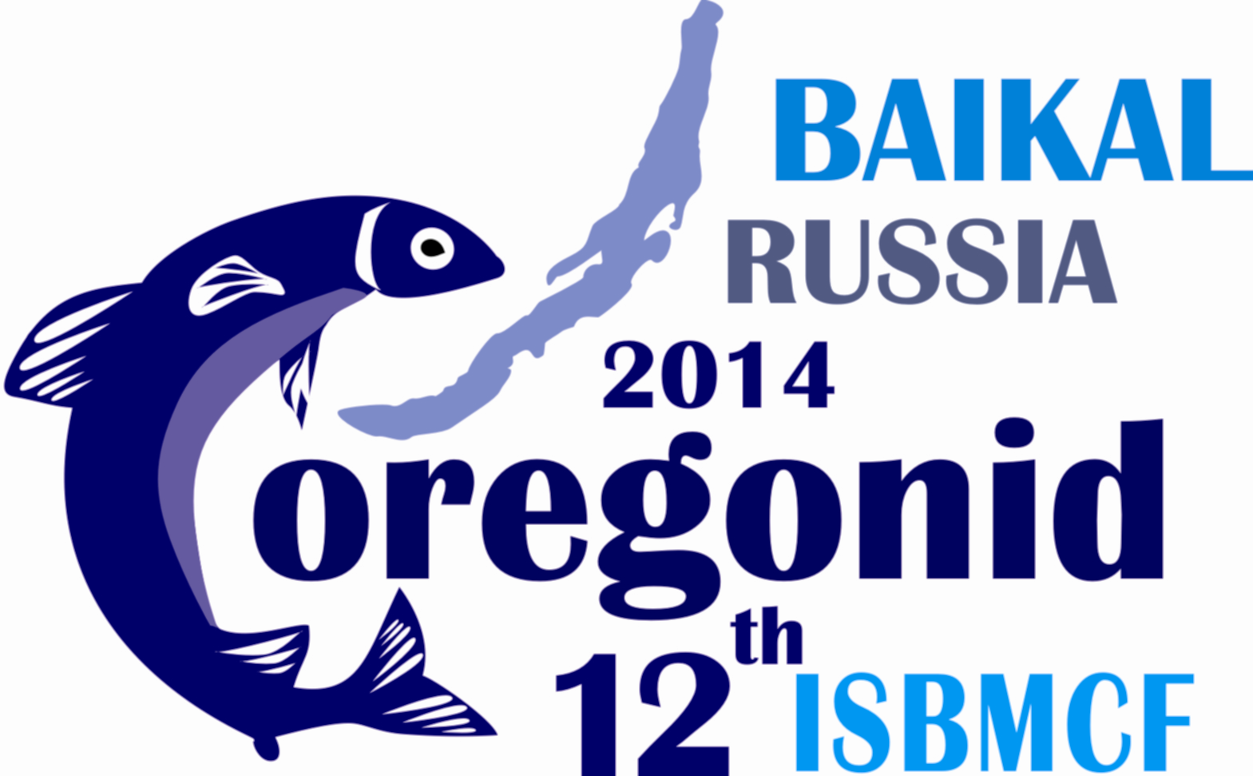
APPLICATION FORM FOR FINANCIAL SUPPORT
for participants from CIS countries and Mongolia only!
no support available for accompanying persons
(see http://en.wikipedia.org/wiki/Member_states_of_the_Commonwealth_of_Independent_States)

Please fill in and return to the Symposium organizer before May 1, 2014.

Name: _______________________________

Address: ______________________________

e-mail: _______________________________

fax: _______________________________

phone: _______________________________

www: _______________________________

Please note that travel costs can only be refunded after original receipts have been handed over to the Symposium organizer in Russia!
__________________________________________________________
Coregonid Symposium organizer:

Limnological Institute SB RAS
3, Ulan-Batorskaya St., P.O. Box 278, Irkutsk 664033, Russia,
Phone (Office) +7 (3952) 422-695
Phone (Mobile) +7 914 00-177-82, +7 924 837-93-82
Fax +7 (3952) 425-405
Symposium website: http://www.lin.irk.ru/symcore2014
E-mail: symcore2014@gmail.com (for registration and correspondence)

APPLICATION FORM FOR FINANCIAL SUPPORT
for participants from CIS countries and Mongolia only!
no support available for accompanying persons

Amount covered by yourself or your institution (e.g. travel fare, visa, etc.)
€ ________

Support requested:

Conference fee
regular participant, student € ________

Accommodation
€ ________

Travel

visa costs € ________

if destination Irkutsk is not possible: round train ticket to Irkutsk € ________

round airfare € _______

Other costs if applicable € ________

Total amount requested € _______

